**NSSA-220 Mini Project 1: Application Performance Monitoring**

**Sarah Pascall and Kyrren Love**

**Introduction**

The goal of this project was to write an Application Performance Monitoring (APM) tool that would monitor the process and system level metrics of a computer for 15 minutes while six executable programs written in C were running. The metrics collected by the APM tool were turned into a series of charts that were used to determine if there was any memory leaks, malicious activity or enough computing resources for the programs being used.

**Process Level Metrics**

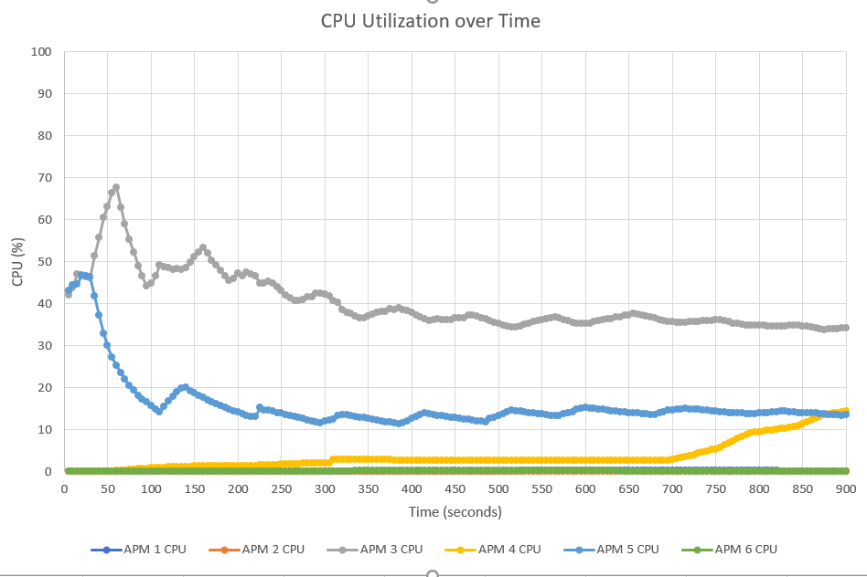

Describe what the CPU utilization plot shows in 2-3 sentences.

APM3 by far used up the most CPU space during its time span. On the other hand, APM1, APM2, and APM6 used the least amount of space on the CPU. The plot shows that the highest rates for most of the APM processes are within the 60 seconds of using them. Over time, all of the APM processes start to slow down - with an exception of APM4 peaking at the end.

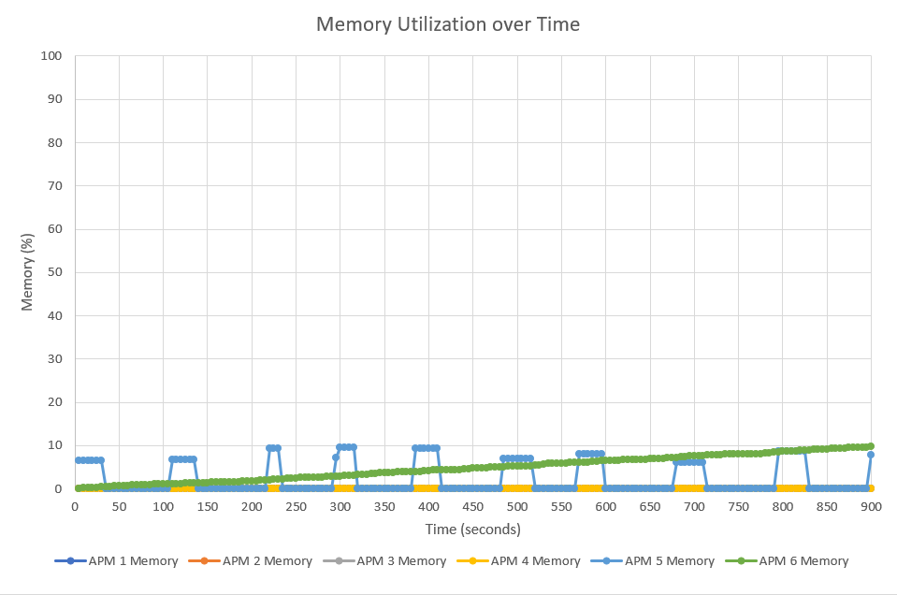

Describe what the memory utilization plot shows in 2-3 sentences.

From the plot, you can see that APM6 was the only tool that had a steady use of memory over the course of 15 minutes. APM5 was the most inconsistent tool because it was up and down over the same period of intervals (closely) and consumed the most memory at a time. From the graph on Memory, we can see that APM6 most likely had a memory leak because it gradually increased over the whole 15 minutes and it never decreased or flatlined.

**System Level Metrics**

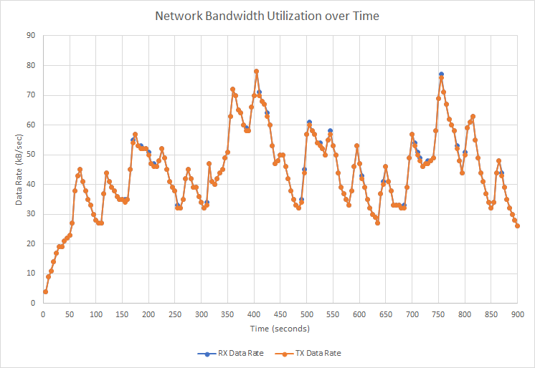

Describe what the network bandwidth utilization plot shows in 2-3 sentences.

The Network bandwidth utilization increased drastically once the processes were started. During the course of 15 minutes, both of the receive (RX) and transmit (TX) data rates stayed relatively equal to each other in terms of bandwidth usage. The average data rate of network bandwidth usage for RX and TX was 44%. Both rates peaked at around 79% of bandwidth usage at approximately the 400 second and 750 second mark - this seems to point to unusual network activity being caused by one or more of the running processes. Both rates showed a gradually decrease around the 850 second mark, possibly indicating that whatever was causing the unusual network activity was finished.

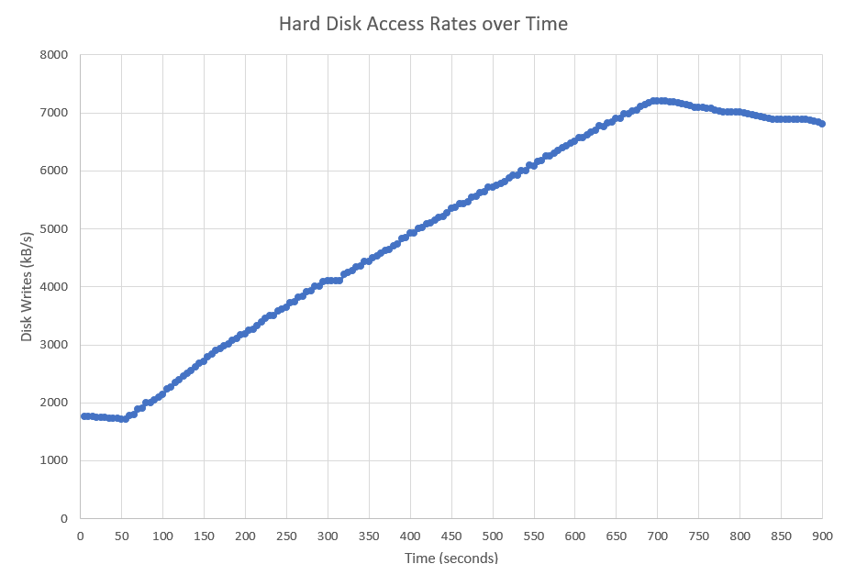

Describe what the hard disk access rates plot shows in 1-2 sentences.

The plot shows that disk write rates over the course of 15 minutes steadily increases to a peak of 7200 disk kB writes/s before seemingly decreasing slowly. The access activity shown seems to be excessive and might indicate the need for a better disk drive.

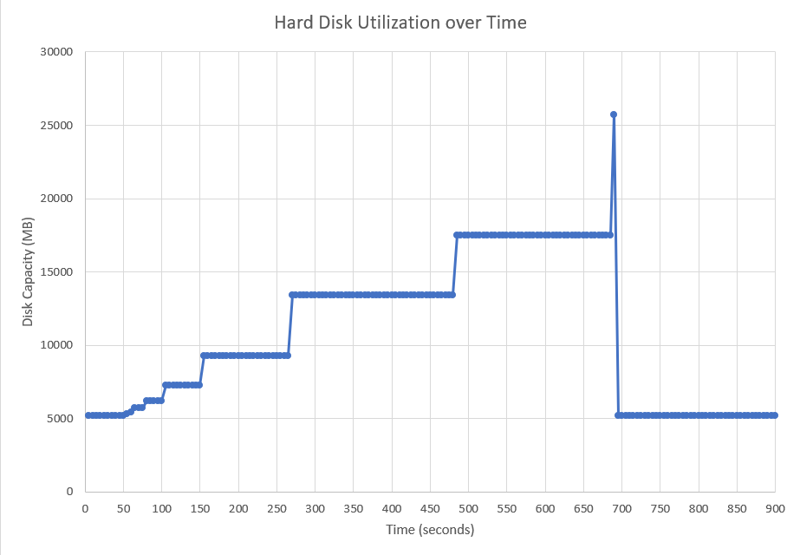

Describe what the hard disk utilization plot shows in 1-2 sentences.

The plot shows that disk capacity starts at 5000 MB and gradually increases until the 100 second mark where it unexpectedly increases a couple thousand MBs before flatlining for 50 seconds. This activity continues where it will increase a few thousand MBs and flatline for a increasingly longer amount of time. However, this activity of increasing and flatling stops at approximately 690 seconds when the disk capacity shoots to 26000MBs, unexpectedly drops back down to the starting capacity of 5000MBs and flatlines until the processes are stopped. The unexpected increases in disk capacity seem to show that there might be some malicious activity causing the unexpected addition of files or programs onto the hard disk - continuing until there is a drastic reduction disk capacity usage showing that the space that was filled has been freed again.

**Summary and Lessons Learned**

The VM seemed to have enough resources to handle all of the processes thrown at it, it was definitely pushed to used its resources for a few of the tools, considering APM6 process seemed to have a memory leak. Additionally, there seemed to be some strange activity going on - indicated by the high amount of network bandwidth, disk access and capacity usage while the process were running. This project was interesting because it helped us better understand the functionality of bash scripting while giving us a great example of how it can be used in a real world setting. A bonus of this project is that we can use the work we did and information we learned while interviewing with companies for potential co-ops.